Introduction to Worldview Analysis

Reading
Sire, J. W. (2009). “Chapter 1 A World of Difference.” In The Universe Next Door: A Basic Worldview Catalog. (5th ed.) Downers Grove, IL: InterVarsity Press, 15–24.

What is a Worldview?
- One’s view of the world.
- A particular philosophy of life or conception of the world.
- The overall perspective from which one sees and interprets the world.
- A collection of beliefs about life and the universe held by an individual or a group.
- “A worldview involves a set or web of ‘controlling beliefs’ by which we interpret our experience of the world.” (Paul Copan, “BIB 4153 03 Christian Values Biblical Faith,” Palm Beach Atlantic University, 2022).

From the German word, Weltanschauung, from Immanuel Kant Welt: world. Anschauung: Perception

The Importance of Understanding Worldviews
- The study and understanding of worldviews lead to a greater ability to make necessary changes in the way you perceive and interact with the world around you.
- Conversely, ignorance of and/or ignoring these matters will often lead to arrogance, cultural blindness, stagnation, and irrelevance.

“Four reasons we need a worldview:
1 to unify thought and life;
2 to clarify the good life/life’s meaning;
3 to guide our thinking (what will help determine what is important to think about, which views are most crucial?);
4 to direct our action (“how should I make moral and practical decisions?”)
Arthur Holmes, Contours of a Worldview (Grand Rapids/Leicester, England: Eerdmans/InterVarsity Press, 1983), 5.”

The Difference it Makes
- It is like asking a Desert tribe member to explain what snow and ice are. It seems completely implausible to him (or her) that water should be able to become as solid as a rock.
- It is not that they cannot understand such things when they have been explained and when they have been exposed to them. It is simply that prior to such an explanation, they have no reference point or conceptual framework for such ideas and facts.

Mangalwadi, Vishal. The Book that Made Your World: How the Bible Created the Soul of Western Civilization. Thomas Nelson, 2011. Pages 60–64.
“In 1976, Ruth and I left urban India to live with the rural poor outside the village of Gatheora. When we arrived, Ruth decided to visit every family in the village. Every day she would visit a few families to find out how we could serve them. On one such visit, Ruth met Lalta, a ten-year-old girl from a low-caste family. She asked Lalta, “How many brothers and sisters do you have?” “Four . . . or maybe three,” Lalta replied. “Is it three or four?” Ruth was curious. “Well, three. The fourth is almost dead.” “May I see him?” The child was a girl named Sheela. In the middle of a windowless, dingy room, an eighteen-month-old living skeleton was lying on a bare string cot, pus oozing from sores covering her body and head, with flies swarming over her because she could not raise her hand to chase them away. Her thighs were only as thick as an adult’s thumb. Sheela was so weak that she could not even cry. She only sighed. Tears welled up in Ruth’s eyes. “What’s wrong with her?” she asked the mother.
“Oh, she doesn’t eat anything,” the mother said with a smirk. “She throws up whatever we give her.” “Why don’t you take her to the hospital?” “How can we afford to see a doctor?” “Really!” Ruth was astonished by the extent of their poverty. “I will pay for her treatment.” “But where is the time to go to the hospital?” protested the mother. “What do you mean? Your daughter is dying and you don’t have the time to take her to the hospital?” “I have three other children,” said the mother, “and a husband to look after. Besides, I can’t find my way around in the hospital.” “Ask your husband to come with you,” Ruth suggested. “He has no time. He has to look after the cattle and the field.” “Tell him I will pay for him to hire someone to look after his field for one day. I will also accompany you. Many hospital staff members are our friends.” The mother found a convenient way to stop being nagged. “I will speak to my husband.” Ruth was delighted. “I will send my husband this evening to talk to your husband. In the morning I will take you to the hospital.” Ruth hurried home to make sure that I would do my part in her mission to save Sheela. When I visited the family that evening, they came out of the house to talk to me. Some neighbors also came out to see what was happening. The couple had decided that they were not going to the hospital. “Why?” I was surprised. “We don’t have the money.” “But my wife told you that we will pay.” “We don’t want to get into debt.” “Well, I’ll put it in writing in front of these witnesses,” I said, pointing to the neighbors, “that we will never ask for the money to be returned to us. It is a gift.” “We don’t have the time.” “But my wife told you that we will pay for you to hire a laborer for the day.” “Why are you bothering us?” They were irritated by my persistence. “She is our daughter.” I couldn’t accept that they wanted their daughter to die, because I didn’t think that a parent could be so cruel. Yet I couldn’t interpret their behavior in any other way. So, I decided to use the pressure of public opinion on them. “Are you killing this girl?” I asked them bluntly in a slightly raised voice. “Of course not! But what can we do if she won’t eat and will vomit everything we give her?” “If you can’t do anything for her, then why don’t you let the doctors do something?” “Because we can’t afford it.” They were as stubborn as I. “Look.” I had run out of patience. “If you don’t take this girl to the hospital tomorrow, then I am going to the police to report that you are killing her. How can you be so cruel? Why don’t you pick up a knife and stab her? Why make her suffer in this way?” Then I turned to the neighbors. “Why don’t you say something? Don’t you care for this helpless girl?” I had expected the neighbors to offer moral support. But they looked at me as though I were a fool. Finally, an elderly neighbor helped resolve our dispute. He said to Sheela’s parents, “Look! He might actually go to the police. If the police take Sheela to the hospital, then you will have to pay the bill. Therefore it is better for you to go with them.” Dr. Mategaonker admitted Sheela and put her on intravenous medication and feeding. After a week or so, the medical staff was able to start feeding her via a nose tube. After another week, they recommended that we take her to our home and keep feeding her fluids through the same tube until she was healthy enough to eat on her own. At that time, our family had begun to expand into a community. A few young people lived with us, including Mark, a student from the HNGR (Human Needs and Global Resources) program at Wheaton College in America. They loved caring for Sheela, including hand-washing her dirty, stinky, cloth diapers. Sheela responded to the love and cuddles as much as to the medication and food. She became a delight. But it didn’t last long. One morning her mother came grumbling, “The village folk are saying that you are corrupting our daughter. If she eats in your home, our caste will be polluted and Sheela will become a Christian.” Ruth tried to assure the mother that she was very welcome to take Sheela home with her. We were pleased with what we had been able to do and were glad to hand Sheela back to her parents. Within a few weeks, however, we learned that Sheela was back to her previous condition. The whole process had to be repeated. Ruth went to persuade the mother. Then I went to persuade and threaten the father. Ruth took Sheela and the mother to the hospital. Sheela was put on an intravenous tube, fed through her nose, and sent to our home. Then her mother came to fight. Ruth assumed that the mother had learned her lesson, so she sent Sheela back to her home again. Before we knew it, Sheela was dead. Sheela’s parents starved her to death because they saw her as a liability. They already had a daughter to babysit their sons and to clean and cook for the family. A second girl was an unnecessary burden. They would have to feed her for ten to twelve years. Then they would need to go into debt to find a dowry to marry her off. Her in-laws might torture her to extract more money from them. In those days, according to our national press, every year in-laws were killing around three hundred young brides in our nation’s capital, in efforts to extract more dowry from their parents.* But a dowry is not the end of costs. The daughter would return to her parents’ home to deliver her children. Why should they take on this lifelong burden, even if someone was offering free medical care and milk for a few weeks? Ruth and I could not understand Sheela’s parents because our worldview was so different from theirs. They looked at children as assets or liabilities, conveniences or burdens. We looked at them as human beings with intrinsic worth. We believed that God’s command, “You shall not murder,” gave to every human person a fundamental right to
life. We did not expect to gain anything from Sheela. We believed that loving God required loving her. We intervened because we believed that God’s Word commanded us to “speak up for those who cannot speak for themselves, for the rights of all who are destitute. Speak up and judge fairly; defend the rights of the poor and needy.”1 From the perspective of their own culture, Sheela’s parents were not wicked people. They were ordinary human beings, as good or bad as anyone else. They loved their children as much as anyone else did. If they had had an American lawyer, he would have argued that they killed their daughter out of love: it was “mercy” killing—euthanasia—and no different than what practically every woman does who aborts her unwanted baby. The parents knew that Sheela’s life as an unwanted girl in their caste and culture was going to be especially miserable; her future was doomed to be dark. Therefore, out of their deep compassion for her they shortened her suffering. This, I believe, was indeed the case. The lawyer would have gone on to argue that people in a more privileged position have no right to judge Sheela’s parents, who were trapped in a closed circle of poverty. Sheela’s parents believed that, like themselves, Sheela was trapped inescapably in the clutches of poverty. They held to traditional Hindu fatalism. They did not believe they could change history—that they could transcend fate and karma, nature and culture. For them it was too revolutionary to think that as human beings they were history shaping, culture creating creatures and that Sheela’s future was not fated to be bleak. Thus our conflict was not merely over ethical principles; it was a clash of worldviews.”

Worldviews shape us
“A worldview isn’t just an “armchair belief” or intellectual theory. It will actually give shape to how we live in the world. And how we live will reflect what we really believe.
For example, to call oneself a Christian but to freely indulge in a sexually indulgent lifestyle means his worldview isn’t a Christian one. The professing Christian doesn’t really live as though there is a personal God who holds us accountable for our actions, that there will be a final judgment, etc. That person is living like a practical atheist.”
Paul Copan. “BIB 4153 03 Christian Values Biblical Faith.” Palm Beach Atlantic University, 2022.

Sire’s Definition
- “A worldview is a commitment, a fundamental orientation of the heart, that can be expressed as a story or in a set of presuppositions (assumptions which may be true, partially true or entirely false) which we hold (consciously or subconsciously, consistently or inconsistently) about the basic constitution of reality, and that provides the foundation on which we live and move and have our being” (James W. Sire, The Universe Next Door: A Basic Worldview Catalog. (5th ed.) Downers Grove, IL: InterVarsity, 2009, 20.)

Sire’s Questions
- What is prime reality-the really real?
- What is the nature of external reality, that is, the world around us?
- What is a human being?
- What happens to a person at death?
- Why is it possible to know anything at all?
- How do we know what is right and wrong?
- What is the meaning of human history?
- What personal, life-orienting core commitments are consistent with this worldview?
James W. Sire, The Universe Next Door: A Basic Worldview Catalog. (5th ed.) Downers Grove, IL: InterVarsity, 2009, 22–23.

Evaluating worldviews
- Origins – where did I come from?
- Meaning – Why am I here?
- Morality – what is right or wrong?
- Destiny – Where are we going?
- Identity – who am I.
- Logical consistency, empirical adequacy, experiential relevance.

Alternate worldview questions
- A narrative component (the storyline).
- A rational component (beliefs, theory).
- A ritual component (practices, behavior).

Seven Basic Question Underlying a Worldview
- Metaphysical (reality)
- Commonsensical (normality)
- Anthropological (humanity)
- Thanatological (Mortality/Immortality)
- Epistemological (Knowability)
- Ethical (Morality)
- Historical (Directionality)
(Paul Copan, “BIB 4153 03 Christian Values Biblical Faith,” Palm Beach Atlantic University, 2022.)

Hiebert’s Definition
- “[A worldview represents] ‘the fundamental cognitive, affective, and evaluative presuppositions a group of people make about the nature of things, and which they use to order their lives.’ Worldviews are what people in a community take as given realities, the maps they have of reality that they use for living.” [Hiebert, P. G. (2008). Transforming Worldviews: An Anthropological Understanding of How People Change. Grand Rapids, MI: Baker Academic.]

Some limitations of worldview analysis
- The tendency to make worldviews fit into a particular way of consistently analyzing all worldviews (i.e., why should the categories of origin, meaning, morality, and destiny be important to every worldview).
- In a sense, each worldview should be assessed by its own standards (and yet there does seem to be some sort of overarching criteria to judge them by, i.e., reason).

CS Lewis
“The most dangerous ideas in society are not the ones being argued, but the ones that are assumed.”

Wilkens, Steve. Hidden Worldviews: Eight Cultural Stories that Shape Our Lives. Downers Grove, IL: InterVarsity Academic, 2009.
Individualism: I Am the Center of the Universe
Consumerism: I Am What I Own
Nationalism: My Nation, Under God
Moral Relativism: The Absolute Truth about Relativism and Something Like Relativism
Scientific Naturalism: Only Matter Matters
The New Age: Are We Gods or Are We God’s?
Postmodern Tribalism: My Tribe/My Worldview
Salvation by Therapy: Not as Good as It Gets

Three Major Worldviews
- Theism (God exists)
- Pantheism (All is god)
- Atheism (God does not exist)

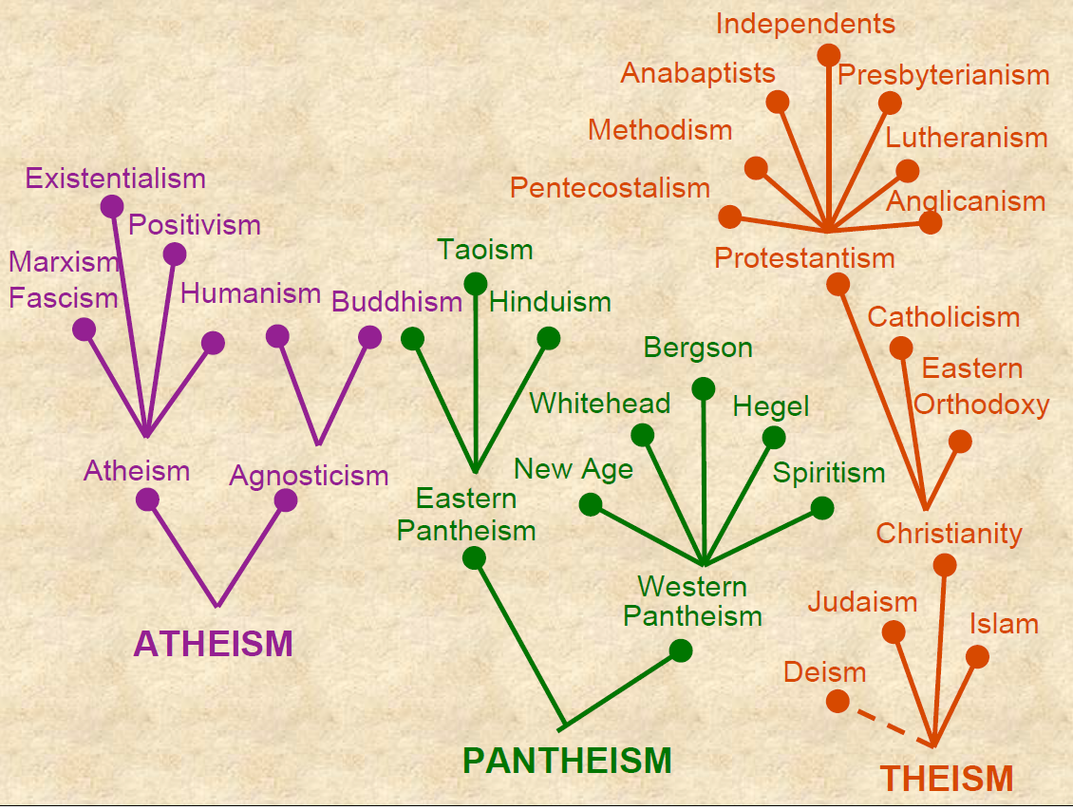

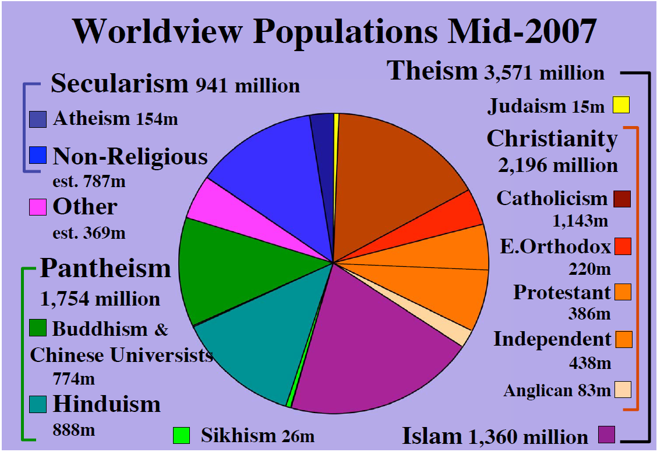

http://www.adherents.com/Religions_By_Adherents.html
Christianity: 2.1 billion
Islam: 1.5 billion
Secular/Nonreligious/Agnostic/Atheist: 1.1 billion
Hinduism: 900 million
Chinese traditional religion: 394 million
Buddhism: 376 million
primal-indigenous: 300 million
African Traditional & Diasporic: 100 million
Sikhism: 23 million
Juche: 19 million
Spiritism: 15 million
Judaism: 14 million
Baha'i: 7 million
Jainism: 4.2 million
Shinto: 4 million
Cao Dai: 4 million
Zoroastrianism: 2.6 million
Tenrikyo: 2 million
Neo-Paganism: 1 million
Unitarian-Universalism: 800 thousand
Rastafarianism: 600 thousand
Scientology: 500 thousand

Question | Atheism | Pantheism | Theism
1. Why is there something instead of nothing? | Something always existed. | Everything that exists is God (non-personal). | An infinite personal God created all that exists from nothing.
1. Why is there something instead of nothing? | The universe is all there is and is here by chance. | Everything that exists is God (non-personal).
2. Why Does Man Exist? | Humanity is only product of chance in a closed universe. | Like all existence humans (atman) are a manifestation of God (Braham) | Humanity was created by God, distinct from all creation.
3. What is the basis of human dignity? | Ultimately nothing. Relatively, social convention. | Nothing. One’s uniqueness separates him from oneness with God. | Humans are made in the image of God and exists for personal relationship with God.
4. What is the basis of personality; that man thinks, wills, has emotions | -Ultimately nothing. | Personality is illusion. One must deny personality to enter into the unity of God. | God is personal (thinks, wills, feels…)
 | -Relatively, evolutionary conditioning. |  | Humanity is made in the divine image.
5. What is the basis for reason and rationality? | -Ultimately nothing. | Nothing. | God is by nature rational, and humans are in His image.
5. What is the basis for reason and rationality? | -Relatively, evolutionary conditioning. | Reason is illusion. | God is by nature rational, and humans are in His image.
5. What is the basis for reason and rationality? | -Relatively, evolutionary conditioning. | Final reality (God) is a-rational. | God is by nature rational, and humans are in His image.
5. What is the basis for reason and rationality? | -Relatively, evolutionary conditioning. | Truth is known by illumination. | God is by nature rational, and humans are in His image.
6. What is the basis of ethics, morals, and values? | -Ultimately nothing. | Nothing. | God’s nature is the good and is revealed Scripture and conscience.
6. What is the basis of ethics, morals, and values? | -Relatively, evolutionary conditioning. | Relatively, the laws of karma.
7. Why is there evil in the universe? | -The universe is amoral (moral evil is merely relative to culture). | Because God is everything, there is no real evil. Hence, the laws of karma are arbitrary. | -Moral evil derives from free agents (Satan, Adam).
7. Why is there evil in the universe? | -Physical evil is a normal part of existence. |  | -Physical evil is a judgment of moral evil.
8. What is the basis of happiness, pleasure, and aesthetic appreciation? | -Ultimately nothing. | Human pleasure separates from God. | Being made in the image of God humans were made to appreciate God and his creation.
 | -Relatively, evolutionary conditioning. | True bliss is only through unity with God (nirvana).
9. What is the of individual in the universe? (The problem of unity and diversity) | Ultimately all is meaningless and has no basis. | Ultimately there is only unity, all individuality is mere illusion (maya). | Christianity: In the Trinity there is unity and diversity in harmony.
 | Ultimately all is meaningless and has no basis. |  | Islam: fatalism, determinism.

Pyramid of Needs
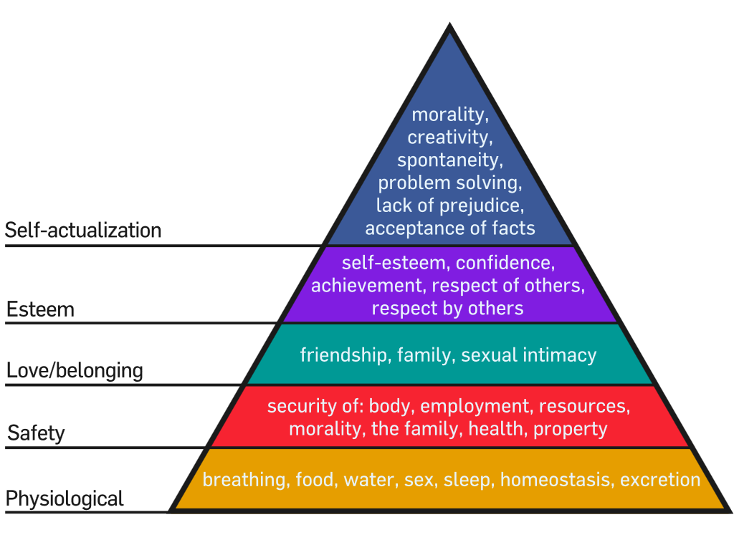
Homeostasis – literally “similar standing,” carries the idea of stability and consistency in life.

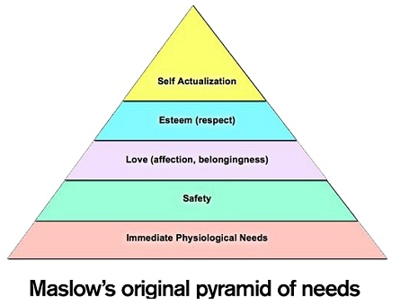

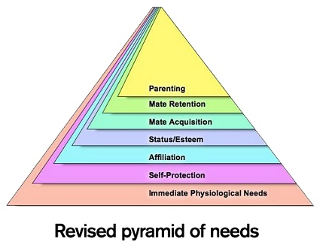
Marlow’s 1940’s
Updated 2010
self-actualization – the desire to fulfill one’s own unique creative potential.
self-actualizing" is finding fulfillment by doing what you most want to do.
At the top of the new pyramid are three evolutionarily critical motives that Maslow overlooked – mate acquisition, mate retention and parenting.
“Reproductive goals are ultimate causes,”

TIME’s 100 most influential ppl of all time
- Homer (from the Iliad and the Odyssey)
- Isaac Newton
- Charles Darwin
- Euripides
- Plato
- The architects of Notre Dame
- Peter Abelard
- Leonardo da Vinci
- Rembrandt
- Wolfgang Amadeus Mozart
- Johann Sebastian Bach
- Ludwig van Beethoven
- William Shakespeare
- Friedrich Nietzsche
- Edmund Kean
- Constantin Stanislavski
- John Donne
- Charlie Chaplin
- Marlon Brando
- Suleiman the Magnificent
- Aristotle
- Thomas Aquinas
- Martin Luther King Jr.
- Mustafa Ataturk
- John Coltrane
- George Washington
- Abraham Lincoln
- Franklin D Roosevelt
- Thomas Edison
- Henry Ford
- Pliny the Elder
- Benjamin Franklin
- Fidel Castro
- Sappho
- Nicolaus Copernicus
- Euclid
- The Prophet Muhammad
- Jesus Christ
- Siddhartha Gautama Buddha
- Confucius
- Johannes Gutenberg
- Galileo Galilei
- Rene Descartes
- Alexander the Great
- Mahatma Gandhi
- Karl Marx
- Sigmund Freud
- Rumi
- Louis Pasteur
- Adolf Hitler
- Geoffrey Chaucer
- Marie Curie
- Genghis Khan
- James Watt
- Napoleon
- Watson and Crick
- Jean-Jacques Rousseau
- William the Conqueror
- Qin Shi Huang
- Albert Einstein
- Moses
- Mark Zuckerberg
- Lao Tzu
- Cyrus the Great
- Marie-Antoine Careme
- Christopher Columbus
- Pericles
- Attila the Hun
- Ashoka the Great
- Hammurabi
- Elizabeth I
- Hildegard of Bingen
- Cleopatra VII
- Joan Arc
- Catherine the Great
- Mary Wollstonecraft
- Louis Daguerre
- Saladin
- Otto the Great
- Frederick the Great
- Ramses the Great
- Constantine the Great
- Martin Luther
- Liu Bang
- Alfred the Great
- Pope Leo the Great
- Gregory the Great
- Ivan the Great
- Niels Bohr
- Wright Brothers
- Zheng He
- Peter the Great
- Augustus
- Pablo Picasso
- John Locke
- Akbar the Great
- Zoroaster
- Adam Smith
- Darius the Great
Joel Stein, “The All-Time TIME 100 of All Time,” Time, Wednesday, Apr. 18, 2012. Available at: http://www.time.com/time/specials/packages/article/0,28804,2111975_2112269_2112278,00.html

Top grossing films of all time
- Avengers Endgame $2.80 billion
- Avatar $2.79 billion
- Titanic $2.19 billion
- Star Wars: The Force Awakens $2.07 billion
- The Avengers: Infinity Wars $2.05 billion
- Jurassic World $1.67 billion
- Marvel’s The Avenger’s $1.52 billion
- Furious 7 $1.52 billion
- The Lion King (2019) $1.52 billion
- Avengers: Age of Ultron $1.41 billion
- Black Panther $1.35 billion
- Harry Potter 7b $1.34 billion
- Star Wars: The Last Jedi $1.33 billion
- Jurassic World: Fallen Kingdom $1.31 billion
- Frozen $1.28 billion
- Beauty and the Beast (2017) $1.26 billion
- Incredibles 2 $1.243 billion
- The Fate of the Furious $1.236 billion
- Iron Man 3 $1.215 billion
- Minions $1.159 billion
http://boxofficemojo.com/alltime/world/

Adjusted for inflation
- Gone with the Wind
- Star Wars
- The Sound of Music
- E.T.: The Extra-Terrestrial
- Titanic
- The Ten Commandments
- Jaws
- Doctor Zhivago
- The Exorcist
- Snow White and the Seven Dwarfs
- Star Wars: The Force Awakens
- 101 Dalmatians
- The Empire Strikes Back
- Ben-Hur
- Avatar
- Avengers: Endgame
- Return of the Jedi
- Jurassic Park
- Star Wars: Episode I - The Phantom Menace
- The Lion King (1994)
https://www.boxofficemojo.com/alltime/adjusted.htm

The Most Influential Places in History
- Sequoia National Park
- Silicon Valley
- The Grand Canyon
- Sutter’s Mill
- Central Park
- Wall Street
- New York City
- Cape Canaveral
- Iguacu National Park Brazil
- Vatican Museums
- Stonehenge, Britain
- Dublin
- Mainz Germany (printing press invented)
- Waterloo
- The Galapagos Rift and Islands
- The Louvre
- The Bastille (medieval fortress in Paris)
- European Central Bank, Frankfurt
- Athens
- Western Wall, Jerusalem
- Calvary Hill, Jerusalem
- Istanbul
- Mecca
- Damascus
- Ethiopia (because the earliest humans fossils are found here)
- Africa (because its the cradle of human evolution)
- The Great Pyramid and Sphinx, Giza
- Timbuktu, Africa (trading post)
- Simien National Park, Ethiopia
- Taj Mahal, India
- Mahabodhi Temple, India (Buddha said to reach enlightenment here)
- Angkor, Cambodia
- Great Barrier Reef, Australia
- Sydney Opera House
- Fukushima, Japan (nuclear disaster)
- Koshima (because of studies on monkeys)
- The North Pole
- The Moon
Nora Volkow, “The Most Influential Places in History.” Time, Monday, Apr. 23, 2012. Available at: http://content.time.com/time/specials/packages/article/0,28804,2112644_2112566,00.html

Most read/sold books in the world (based on the last 50 years)
- The Bible 3900 million
- Quotations from the Works of Mao Tse-tung 820 mill
- Harry Potter by J.K. Rowling 400 million
- Lord of the Rings by J.R.R. Tolkien 103 mill
- The Alchemist by Paulo Coelho 65 mill
- The Da Vinci Code by Dan Brown 57 mill
- The Twilight Saga by Stephenie Meyer 43 mill
- Gone with the Wind by Margaret Mitchell 33 mill
- Think and grow rich by Napoleon Hill 30 mill
- The diary of Anne Frank 27 mill
Jennifer Polland, “The 10 Most Read Books In The World [Infographic],” Business Insider. Dec 28, 2012. Available at: https://www.businessinsider.com.au/the-top-10-most-read-books-in-the-world-infographic-2012-12

Most-visited sites on the web
- Google
- YouTube
- Facebook
- Baidu.com
- Wikipedia
- Yahoo.com
- Google.co.in
- Reddit
- Qq.com
- Taobao.com
https://www.webhostface.com/blog/top-10-most-popular-websites-for-2017/

Anderson, James N. What's Your Worldview? An Interactive Approach to Life's Big Questions Wheaton, IL: Crossway, 2014.
Do you have the power to make free choices?
Is there any objective truth? | No | Relativism
Is it possible to know the truth? | No | Skepticism
Is anything objectively good or bad? | No | Nihilism
Is there more than one valid religion? | Yes | Pluralism
Is there a God? | No | Atheist
Is everything ultimately one? | Yes | Monism
Is everything ultimately material in nature? | Yes | Materialism
Is everything ultimately mental in nature? | Yes | Atheistic Idealism
Is God a personal being? | No | Quasi-Theist Worldviews
Is the universe God? | Yes | Pantheism
Is the universe within God? | Yes | Panentheism
Is God a perfect being | No | Finite Theist Worldviews
Is there only one God? | No | Polytheism
Has God communicated with humans? | No | Deism
Has God communicated openly to humans? | No | Mysticism
Did Jesus of Nazareth rise from the dead? | No | Non-Christian Theist Worldviews
Was Muhammad a true prophet of God? | Yes | Islam
Was Moses a true prophet of God? | Yes | Judaism
Was Jesus of Nazareth Divine? | No | Unitarianism
Do good people go to heave and bad people to hell? | Yes | Pelagianism
 | No | Christianity

Australian census 2016 religion
2016 | 2011
No religion – 30.1% | Catholic – 25.3%
Catholic – 22.6% | No religion – 22.3%
Anglican – 13.3% | Anglican – 17.1%
Uniting Church – 3.7% | Uniting Church 5.0%
Christian, (Not further defined)– 2.6% | Presbyterian and Reformed – 2.8%
Islam – 2.6% | Eastern Orthodox – 2.6%
Buddhism – 2.4% | Buddhism – 2.5%
Presbyterian and Reformed – 2.3% | Islam 2.2%
Eastern Orthodox – 2.1% | Christian (Not further defined) 2.2%
Hinduism – 1.9% | Baptist – 1.6%
Baptist – 1.5% | Hinduism 1.3%
Pentecostal – 1.1% | Lutheran – 1.2%
Lutheran – 0.7% | Pentecostal 1.1%
Sikhism – 0.5% | Judaism – 0.5%
Other Protestant – 0.5% | Jehovah’s Witnesses – 0.4%
Judaism – 0.4% | Sikhism – 0.3%
Jehovah’s Witnesses – 0.4% | Seventh–day Adventist – 0.3%
Seventh-day Adventist – 0.3% | Other Protestant – 0.3%
Latter-day Saints – 0.3% | Salvation Army – 0.3%
Oriental Orthodox – 0.2% | Latter-day Saints – 0.3%
http://www.abs.gov.au/AUSSTATS/abs@.nsf/mediareleasesbyReleaseDate/7E65A144540551D7CA258148000E2B85?

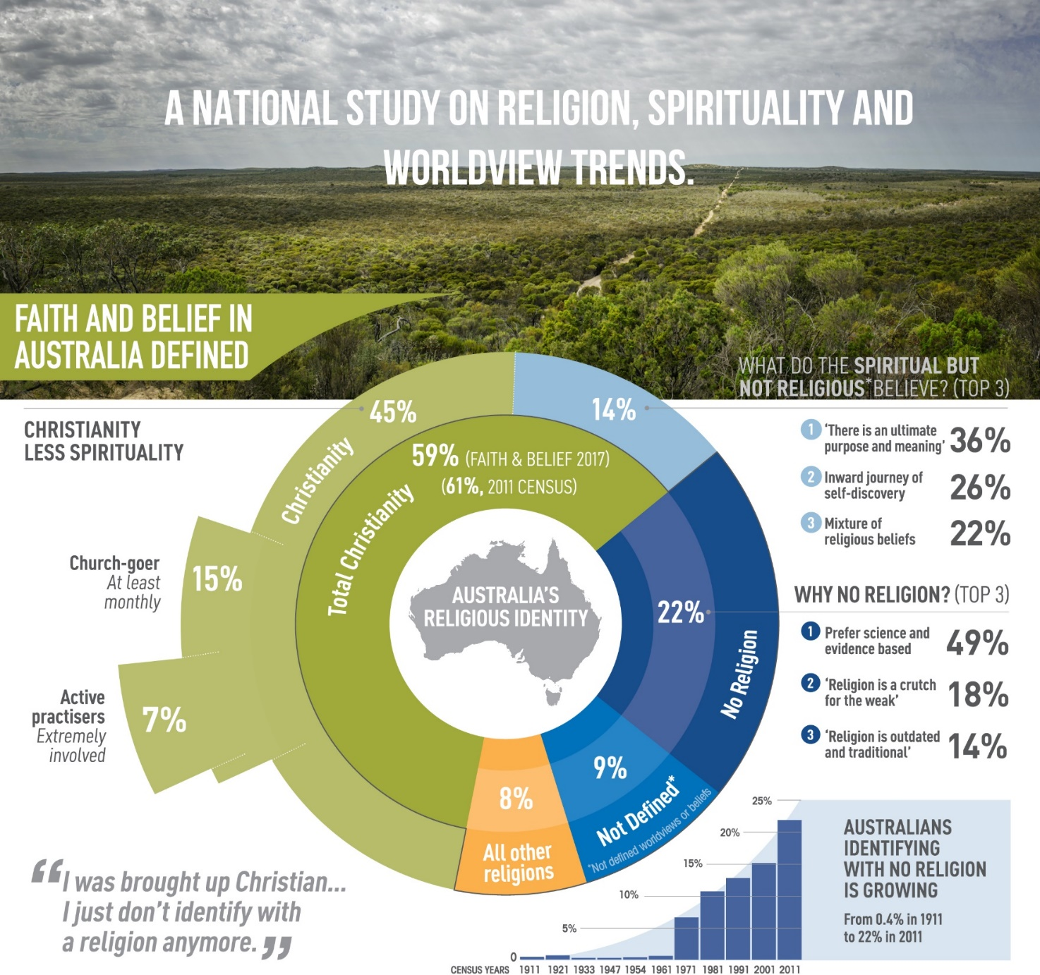
http://faithandbelief.org.au/

Pocahontas: Colors of the Wind
You think I'm an ignorant savage
And you've been so many places
I guess it must be so
But still I cannot see
If the savage one is me
How can there be so much that you don't know?
You don't know ...
You think you own whatever land you land on
The Earth is just a dead thing you can claim
But I know every rock and tree and creature
Has a life, has a spirit, has a name
You think the only people who are people
Are the people who look and think like you
But if you walk the footsteps of a stranger
You'll learn things you never knew you never knew
Have you ever heard the wolf cry to the blue corn moon
Or asked the grinning bobcat why he grinned?
Can you sing with all the voices of the mountains?
Can you paint with all the colors of the wind?
Can you paint with all the colors of the wind?
Come run the hidden pine trails of the forest
Come taste the sunsweet berries of the Earth
Come roll in all the riches all around you
And for once, never wonder what they're worth
The rainstorm and the river are my brothers
The heron and the otter are my friends
And we are all connected to each other
In a circle, in a hoop that never ends
How high will the sycamore grow?
If you cut it down, then you'll never know
And you'll never hear the wolf cry to the blue corn moon
For whether we are white or copper skinned
We need to sing with all the voices of the mountains
We need to paint with all the colors of the wind
You can own the Earth and still
All you'll own is Earth until
You can paint with all the colors of the wind

Some Factors Influencing One’s Worldview
- Gender, age, culture (family and ethnic), personal circumstances, historical era, socio-economic, theological/religious tradition, education, geography, language.

Illustration of How Societies View Those Who Are Different
- Asian societies tend to ostracize and vilify such figures (“The nail that sticks up gets hammered down.”), whereas American society, for example, tends to see them as courageous heroes.

Affective Elements to Worldviews
- It is important to consider emotions.
- Anger: Something important to you is being violated. There is a sense that some injustice has occurred to you or something/someone that you care about and matters to you.
- Sadness: Something has happened that you did not want to happen, it causes you pain and you cannot really do anything about it.

Symbols
- Symbols – i.e., wearing a ring on your left hand, fourth finger in modern western culture indicates you are married.
- Symbols become natural to us, and we don’t think about it – i.e. red-light signals while driving means stop.
- Calling someone an Ox in the US means you are intellectually slow, but in Africa it might symbolize strength.

Culture Analysis
- What does “McDonalds” say about American culture?
- What can we learn about how professors dress?
- Would you eat in a car?

What can we learn from these ads?
- Apple vs PC – Promises video 0:30
- Apple vs PC – Support Group video 0:30
- Apple vs PC – Customer Care video 0:30
- Blackberry video 0:47
- Pepsi video 1:30
- World cup video 3:00

What is it like to travel?
- For a short holiday?
- For long term?

Taxonomy
- Group the items into categories:
- tree, dog, woman, fly, lion, man, sand, god, virus, demons, bush, girl, rock, cow, flower, bug, angels, bacteria, ant, mickey mouse

Analysis
- Locution – the act of expressing something
- Illocution – what you are doing by what you are saying
- Perlocation – the effect of what you are doing

Conversation
- Locution – i.e. the words “do you want to wash the dishes?”
- Illocution – i.e. an imperative that she wants him to get up and do something
- Perlocation – i.e. the husband got up and actually did it

Architecture – A building
- Locution – the beams that hold up a structure, concrete, steel…
- Illocution – it shows how rich owners are and how much power they have…
- Perlocation – people react to how great the building is

Movie - Star Trek
- Locution – the raw data, the actors, special effects, music
- Illocution – entertainment, transporting their fantasy world view
- Perlocation – the spectator's agreement of other worldviews
- (Originally the producers wanted a maximally diverse culture – now they include not only different ethnic groups but also different races aliens and humans together. The only real evil is the assimilation of the Borg.)

Analyzing Australian Culture

Definition of Culture
- Hiebert defines culture as "the more or less integrated system of ideas, feelings, and values and their associated patterns of behavior and products shared by a group of people who organize and regulate what they think, feel, and do.” Hiebert, Anthropologic Insights for Missionaries, USA: Baker, 1986, Pg 30.

Definition of Religion
- “All specific beliefs about the ultimate nature of reality and the origins, meanings, and destiny of life, as well as the myths and rituals that symbolically express them.” Pg 372, Hiebert

Jim Carrey
- “I’ve often said that I wish people could realize all their dreams and wealth and fame so that they could see that it’s not where you’re going to find your sense of completion” (commencement speech (2014) at Maharishi University of Management, Fairfield, Iowa).

Getting to know you
- What is one of your favorite movies?
- Favourite foods, songs, places to go, holiday destination, hobbies, sports, books, games…

