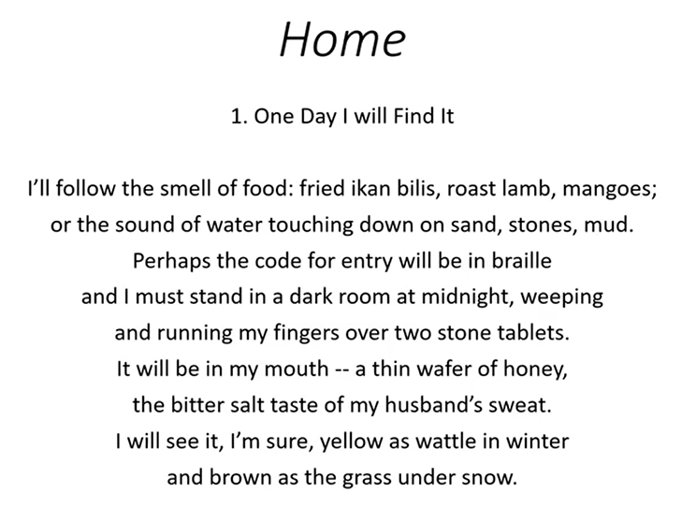
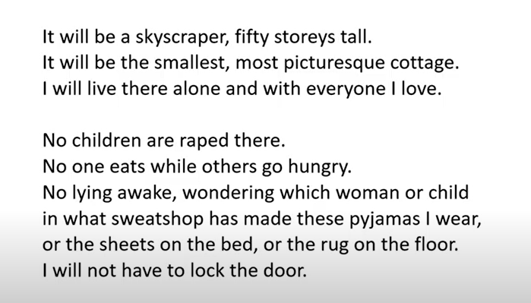
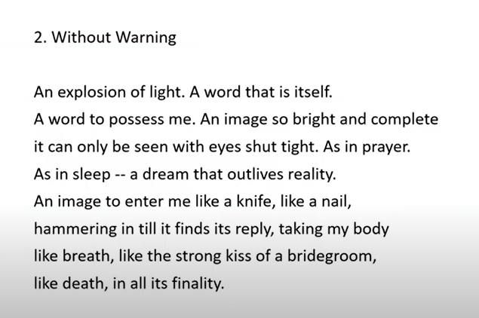
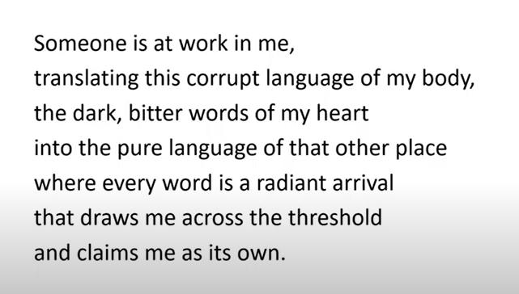

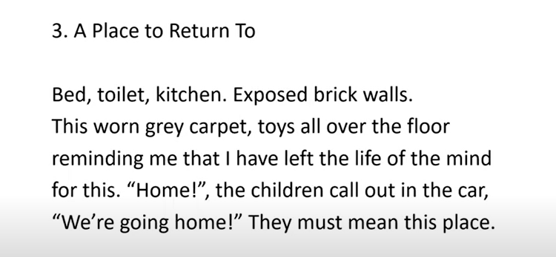
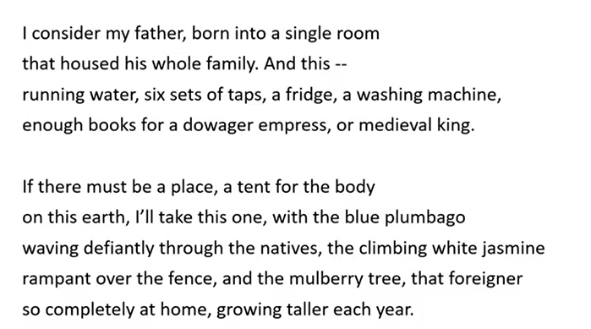
Lo, M.W.W. (2013). “Home”. In A. Aitken, K.C. Boey & M. Cahill (Eds.) Contemporary Asian Australian Poets, (pp.148-9). Glebe, NSW: Puncher and Wattman Poetry.

Discussion Questions:

- Where is ‘home’ according to the poet? ( 10 marks)
- Comment on the references ( Biblical or others) in the poem.
- Comment on the use of the metaphor ‘mulberry tree’.

